Annual Departmental Assessment Report

Department or Program: Chemistry & Biochemistry
Academic Year of Report: 2018 - 2019
Department Contact Person for Assessment: Michael Koscho

Section 1: Learning Objectives Assessed for this Report

The learning objectives assessed during this period are described below as learning goals 1 and 2 and are the same for both our Chemistry and Biochemistry majors. Figure 1 documents how the number of students we serve has increased over the past 20 years peaking from 2013 to 2016.

Learning Goal 1: Master a broad set of chemical concepts concerning the fundamentals in the basic areas of the discipline (organic, inorganic, analytical, physical and biochemistry). Students will demonstrate an understanding of structure, chemical properties, and reactions of chemicals and biomolecules.

Learning Goal 2: Demonstrate a firm foundation in the conceptual, quantitative, and computational thinking that underlies the theories and models that form the basis for reasoning about molecular systems. Students should be able to connect this theoretical understanding to the experimental methods used to test those theories and models.

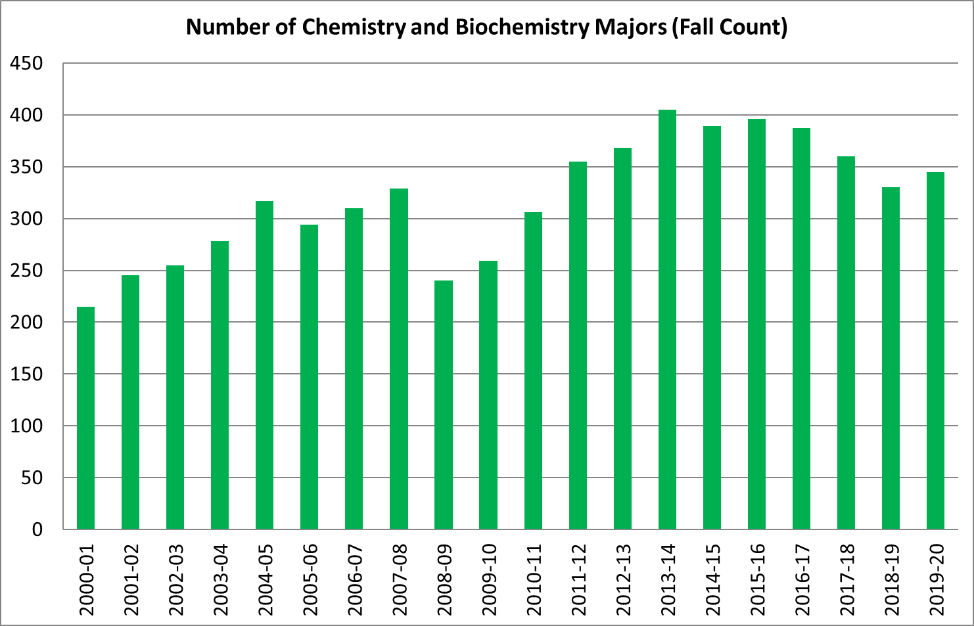
Figure 1. Number of Chemistry and Biochemistry Majors over Time. Shows the total number of chemistry majors and biochemistry majors per year since 2000.

Section 2: Assessment Activities

Learning Goal 1: Master a broad set of chemical concepts concerning the fundamentals in the basic areas of the discipline (organic, inorganic, analytical, physical and biochemistry). Students will demonstrate an understanding of structure, chemical properties, and reactions of chemicals and biomolecules.

During the last assessment period our faculty identified and evaluated tools to assess the mastery of a broad set of chemical concepts for our majors. The American Chemical Society (ACS) – Division of Chemical Education Examinations Institute provides national exams that can be used to assess student performance at different stages of the chemistry curriculum. One advantage of this approach is that the exams institute provides a tool that compares the performance of our students with student performances from other US schools. This will enable us to track internal and external performance from year to year and potentially identify gaps in our curriculum.

Our faculty reviewed many ACS exams and chose the General Chemistry ACS exam (which is actually three exams that students take as their final exam for each term of General Chemistry), and the DUCK18 – 2018 Diagnostic of Undergraduate Chemical Knowledge—was chosen as a senior level exam. The General Chemistry exams were administered as the Final Exam for the first term of General Chemistry (CH 221) in the fall 2019. The other two exams will be given as final exams for the Winter and Spring general chemistry courses (CH 222 and CH 223).

Learning Goal #2: Demonstrate a firm foundation in the conceptual, quantitative, and computational thinking that underlies the theories and models that form the basis for reasoning about molecular systems. Students should be able to connect this theoretical understanding to the experimental methods used to test those theories and models.

Because chemistry and biochemistry are experimental sciences, it is vital for students to undertake research projects. One conclusion from our previous assessment report was that we wanted to invest more resources into supporting and growing our undergraduate research community. During the Fall of 2018 we hosted our first ever meet-and-greet and we hosted a Faculty Research Showcase event during the Winter 2019 term. Our goal is to host community building events each quarter. The number of CH and BIC majors who are doing undergraduate research is shown in Figure 2. There is some growth in the number of undergraduate researchers comparing academic years 2018-2019 and 2019-2020.

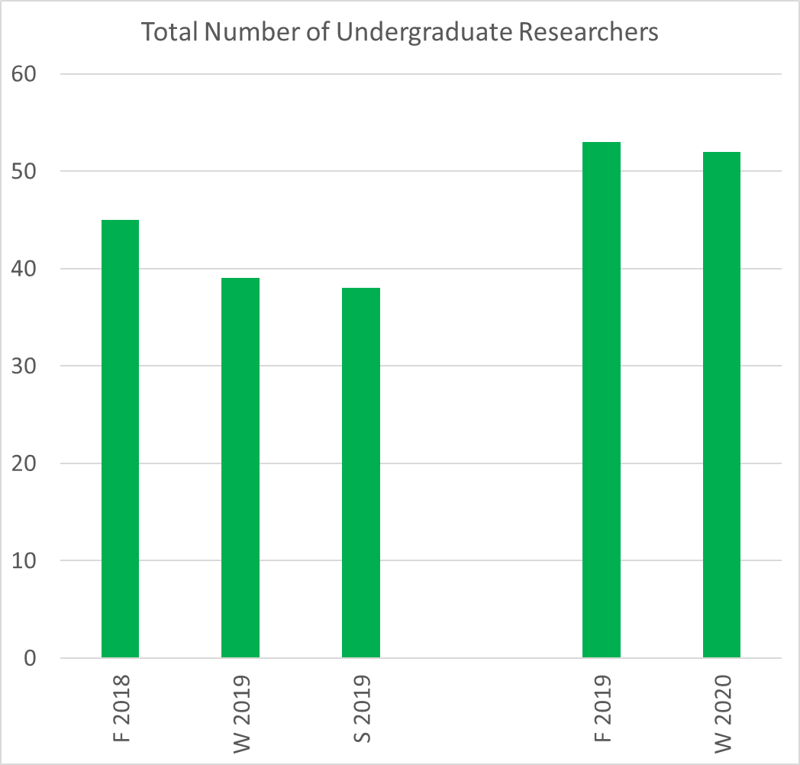
Figure 2. Number of Chemistry and Biochemistry Majors who are working in a research lab.

Section 3: Actions Taken Based on Assessment Analysis

We will continue to host a quarterly event that brings together our undergraduates and faculty so that they can have informal discussions about research. We will continue to track the number of undergraduate researchers over time to assess its effectiveness. In addition, in order to fully asses the learning outcomes for these students we will be tracking the number of publications where the undergraduates are a co-author, and the number of research presentations given by the undergraduates at regional and national conferences.

We will continue administering the General Chemistry ACS exam in order to be able to compare our students’ performance with national averages. Additionally, we will determine a way to administer the DUCK18 senior level exam.

Section 4: Other Efforts to Improve the Student Educational Experience

We are increasing the number and diversity of upper division advanced electives for our majors. The lack of advanced electives, especially for our biochemistry majors, has been a significant challenge. We used to encourage our biochemistry majors to enroll in appropriate advanced electives offered in the Biology department but, due to capacity issues, Biology only reserves two seats per class for biochemistry majors. This drives our majors to change their major to Biology in order to get priority registration access or change to majors like human physiology that have fewer logistical challenges.

During the 2018-2019 academic year there were four advanced electives offered by our department specifically targeted to biochemistry majors (where at least one of the biochemistry courses, CH 461-463, are a pre-requisite). Also, the department offered six experimental courses (CH 410) during the academic year which were taken by both chemistry and biochemistry majors. One of these courses, Cellular Biochemistry, is currently in the approval process to become a permanent course (CH 468).

In addition to advanced elective courses, the department also needs to offer advanced labs. This has been challenging given that the instructional lab space is currently at maximum capacity. Recently, with remodeling of the third floor of Klamath Hall, space has become available on the third floor of Onyx (since research labs are relocating into the newly remodeled space). If the chemistry department can use this space, we would be able to add an array of advanced lab courses for our majors. Plans to teach an advanced inorganic lab and an advanced biochemistry lab are in place just awaiting lab space.

Section 5: Plans for Next Year

As discussed above, we will begin assessing learning outcome #1 by using a comprehensive chemistry exams provided by the American Chemical Society (ACS). We will also continue to assess learning outcome #2 by tracking how many of our majors work in a research lab and tracking the number of presentations and publications that result from their research.

Budgetary implications include the costs for collecting and analyzing data, hosting quarterly events and purchasing ACS exams.

