File Size and Upload Issues
Error When Uploading Documents
If you see the following error when uploading attachments to a dossier, it's likely due to a file size issue. All files must be 50MB or less, see instructions below for optimizing and reducing file size. If the file size is below 50MB and you still encounter this issue, please reach out to elementshelp@uoregon.edu or submit a support ticket.
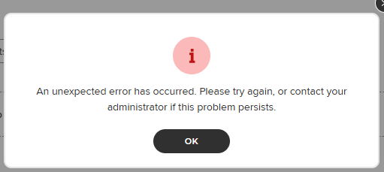
Compressing Files
To reduce file size you can compress a PDF from within the “All Tools” menu in Adobe Acrobat. After selecting “Compress a PDF” from the “All tools” menu, I would first use the “Single file” option under the “Reduce File Size” menu that appears. Check the file size after reducing and saving the document. If further compression is needed you can use the “Advanced Optimization” options. A video tutorial and more details about the process are available here.

There are additional resources here for optimizing file size:
- Optimizing Videos
- Compressing PDFs

Adding a Link to Documents in the Dossier
If there are video or image files over the 50MB limit after compression they can be shared by creating a OneDrive folder and providing the link in the Elements dossier in the appropriate section. We recommend setting the share permissions to be as accessible to reviewers as possible to ensure a smooth process. And we recommend using a role account to develop the OneDrive or SharePoint folder.

