New Core Education Requirements

Course Approval Process and Templates

The Senate passed legislation in 2018-19 changing requirements for courses that meet “Areas of Inquiry” (formerly “Group-Satisfying”) and Cultural Literacy (formerly “Multicultural”). Courses that satisfy an Area of Inquiry must now also satisfy a new requirement: two of four “Methods of Inquiry.” Courses that met the old Multicultural criteria will now need to meet one of two sets of criteria under Cultural Literacy.
NEW
OLD

PROCESS

Courses that currently satisfy an Area of Inquiry will continue to satisfy that area. Courses that met the old Multicultural requirement have been placed into one of the new categories under Cultural Literacy. All courses will need to be resubmitted during either AY 2019-‘20 or AY 2020-‘21 for reapproval under the new criteria. Reapproval for those courses will happen in summer 2020 or 2021.

Courses seeking to satisfy an Area of Inquiry or Cultural Literacy (or both) for the first time will need to meet all the relevant criteria and should be submitted as part of the regular course approval process during the academic year.

See the following pages for process and required templates.

The UOCC will be looking particularly at how course proposals address the following justification statement on the CourseLeaf form:

“Please describe how this course has been designed to fulfill the criteria of the core education requirement(s) selected. Please provide specific references to readings and assignments from the syllabus that address the criteria and outcomes for the Area of Inquiry chosen, and the Core Education Methods of Inquiry chosen.”

To create effective proposals, and to help UOCC efficiently and effectively review those proposals, use the templates below to describe how your course meets the Methods of Inquiry and/or Cultural Literacy criteria.

There is a template for each Method of Inquiry, and for the each of the Cultural Literacy areas. Complete the template for each of the Methods of Inquiry and/or Cultural Literacy areas that apply to your course. See page 5 for an example of how to do that.

***Make sure that any activities or assignments listed in the templates are consistent with the Student Engagement Inventory on CourseLeaf and with what is on the syllabus that will be submitted with the course proposal.***

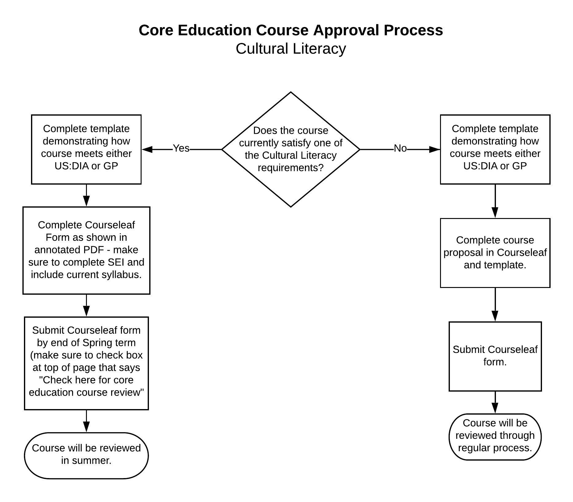
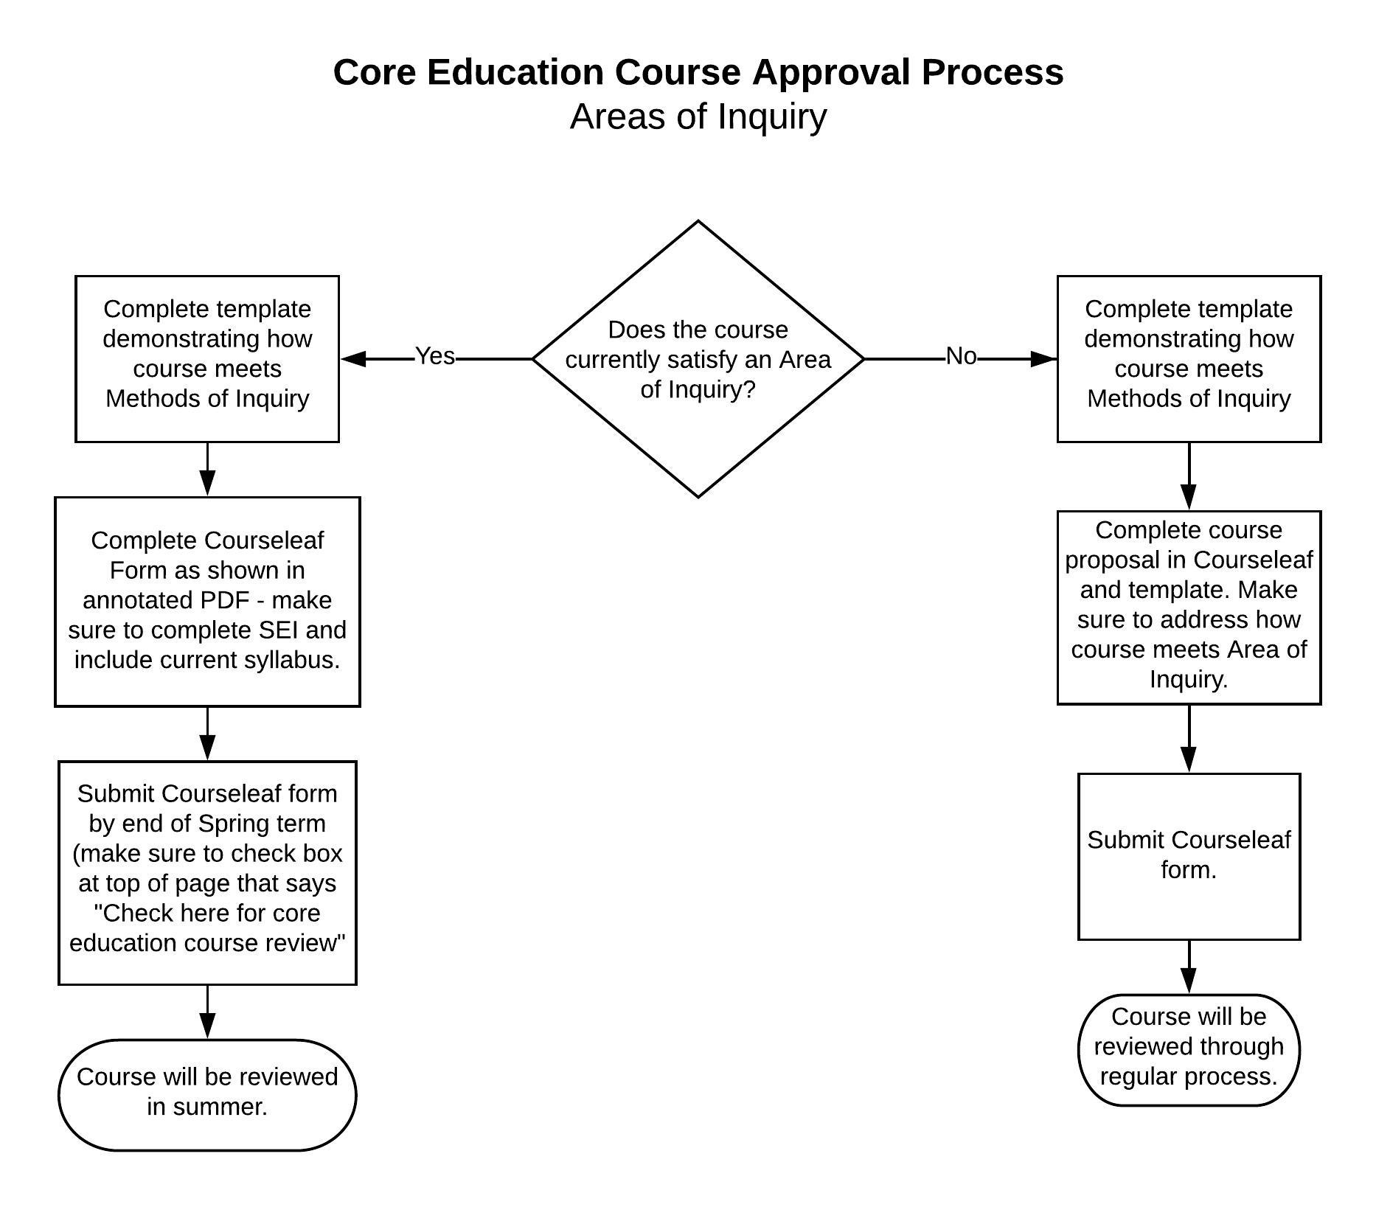
PROCESS
Checklist for courses that currently meet Area of Inquiry and/or Cultural Literacy requirement:

- Completed templates for Methods of Inquiry and/or Cultural Literacy
- Completed SEI in CourseLeaf
- Completed Student Learning Outcomes in CourseLeaf
- Uploaded syllabus that matches SEI, course description and what is in templates
- NO OTHER CHANGES made to course
- Checked box at top of CourseLeaf form for core education summer review

Checklist for courses that are seeking Area of Inquiry and/or Cultural Literacy status for first time:

- Completed templates for Methods of Inquiry and/or Cultural Literacy
- Uploaded syllabus that matches SEI, course description and what is in templates
- If seeking Area of Inquiry, described how course meets Area of Inquiry in CourseLeaf
- Completed entire CourseLeaf form
- DID NOT Check box at top of CourseLeaf form for core education summer review

AREAS OF INQUIRY

Courses that are seeking approval for an Area of Inquiry (Arts & Letters, Social Science or Natural Science) for the first time will need to satisfy the criteria for the Area of Inquiry; and include at least 2 Methods of Inquiry (see pp. 4-8). General criteria for Areas of Inquiry are found below. See the following link for more specific guidelines for new Area of Inquiry courses: https://bit.ly/2Pt64T2

Arts & Letters
Courses must create meaningful opportunities for students to engage actively in the modes of inquiry that define a discipline. Proposed courses must be broad in scope and demonstrably liberal in nature (that is, courses that promote open inquiry from a variety of perspectives). Though some courses may focus on specialized subjects or approaches, there must be a substantial course content locating that subject in the broader context of the major issues of the discipline. Qualifying courses will not focus on teaching basic skills but will require the application or engagement of those skills through analysis and interpretation.

Social Sciences
Courses must be liberal in nature rather than being professionally oriented or limited to the performance of professional skills. They must cover a representative cross-section of key issues, perspectives, and modes of analysis employed by scholars working on the subject matter addressed by the course. The subject matter of the course will be relatively broad, e.g., involving more than one issue, place, or time. Courses with an emphasis on methods and skills will satisfy the requirement only if there is also a substantial and coherent theoretical component.

Natural Sciences
Courses should introduce students to the foundations of one or more scientific disciplines; or should provide an introduction to fundamental methods (such as mathematics) that are widely used in scientific disciplines. Courses should introduce students to the process of scientific reasoning.

*** Only courses that are seeking approval to meet an Area of Inquiry for the first time need to provide evidence as to how the course meets the Area criteria. Courses that currently satisfy an Area of Inquiry should skip this step.***

METHODS OF INQUIRY TEMPLATES

***Sample*** Written Communication
Through iterative experiences across the curriculum, students will develop the capacity to develop and express ideas in writing, to work in different genres and styles, work with different writing technologies, and mix texts, data, and images to effectively communicate to different audiences.

Course will engage students in developing at least half of the following:
- Context of and purpose for writing: considerations of audience, purpose, and the circumstances surrounding the writing task(s).
- Content development.
{
- Genre and disciplinary conventions: formal and informal rules inherent in the expectations for writing in particular forms and/or academic fields.
- Sources and evidence.
- Control of syntax and mechanics.

***For each Method of Inquiry, at least half of the criteria must be addressed. For each criterion, provide at least one example in the table of an activity or assignment that will be used to address that criterion.***

Which criterion?  (must address 3 of 5) | Please describe how this course has been designed to fulfill the selected core education criterion: What kinds of activities, assignments, experiences allow students to practice and/or demonstrate attainment of the criterion? Please provide specific examples of activities, assignments, or experiences from the syllabus. You are also welcome to upload additional course materials as illustrations.
3, 4  (an assignment or activity can address more than one criterion) | 5-page paper arguing for the inclusion of a film, novel, or other work on the required reading list for future iterations of course.
5 | Each quiz (10 total) includes two multiple choice questions asking students to select the grammatically correct answer.
Critical Thinking
Students will develop the skills and habits of mind necessary for the comprehensive exploration of issues, ideas, artifacts, and events in the evaluation and formulation of opinions and conclusions. Critical thinking requires students to question critically, think logically and reason effectively in the context of discipline-specific methodologies.
Course will engage students in developing at least half of the following:
- Explanation of issues, assumptions, or hypotheses.
- Using relevant and credible evidence, information, or hypotheses to describe, investigate or analyze a situation, or draw a conclusion.
- Facility with methods of reasoning appropriate to the discipline (such as inductive, deductive, scientific, or esthetic reasoning, or statistical inference).
- Modeling: capturing the essentials of a situation in language or symbolism suitable for deriving conclusions about it.
- Influence of context and assumptions.
- Logical conclusions and related outcomes (implications and consequences).

Which criterion?  (must address 3 of 6) | Please describe how this course has been designed to fulfill the selected core education criterion: What kinds of activities, assignments, experiences allow students to practice and/or demonstrate attainment of the criterion? Please provide specific examples of activities, assignments, or experiences from the syllabus. You are also welcome to upload additional course materials as illustrations. (Add rows to the table as needed)

Creative Thinking
Students will develop the capacity to combine or synthesize existing ideas, images, or expertise in original ways. Students will work in imaginative ways characterized by a high degree of innovation, divergent thinking, and risk taking.

Course will engage students in developing at least half of the following:
- Acquiring competencies: acquiring strategies and skills within a particular domain.
- Taking risks: going beyond original parameters of assignment, introducing new materials and forms, tackling controversial topics, advocating unpopular ideas or solutions.
- Solving problems.
- Innovative thinking: connecting, synthesizing or transforming ideas in discipline-specific ways.
Which criterion?  (must address 2 of 4) | Please describe how this course has been designed to fulfill the selected core education criterion: What kinds of activities, assignments, experiences allow students to practice and/or demonstrate attainment of the criterion? Please provide specific examples of activities, assignments, or experiences from the syllabus. You are also welcome to upload additional course materials as illustrations. (Add rows to the table as needed)

Written Communication
Through iterative experiences across the curriculum, students will develop the capacity to develop and express ideas in writing, to work in different genres and styles, work with different writing technologies, and mix texts, data, and images to effectively communicate to different audiences.

Course will engage students in developing at least half of the following:
- Context of and purpose for writing: considerations of audience, purpose, and the circumstances surrounding the writing task(s).
- Content development.
- Genre and disciplinary conventions: formal and informal rules inherent in the expectations for writing in particular forms and/or academic fields.
- Sources and evidence.
- Control of syntax and mechanics.

Which criterion?  (must address 3 of 5) | Please describe how this course has been designed to fulfill the selected core education criterion: What kinds of activities, assignments, experiences allow students to practice and/or demonstrate attainment of the criterion? Please provide specific examples of activities, assignments, or experiences from the syllabus. You are also welcome to upload additional course materials as illustrations. (Add rows to the table as needed)

Ethical Reflection
Students will develop the capacity to identify, examine, and critically revise ethical positions, map them onto larger ethical ideas (theoretical traditions, moral frameworks, prevailing social frameworks), and reflect on how decisions and actions (including, sometimes, inaction) shape our relations to others and self. Students will develop the capacity to articulate the ends sought in a range of endeavors in personal, social and professional contexts. Students also will develop concepts, practices, and other tools appropriate to valuing those ends in relation to their means of attainment and their impacts on self and others.

Course will engage students in developing at least half of the following:
- Awareness of one’s own values and capacities for self-questioning.
- Language and tools to examine ethical issues, including discipline-specific frameworks.
- Recognition of the presence of ethical issues, especially where typically neglected.
- Awareness of the impact of our decisions and actions (both personally and as members of groups).
- Application of ethical inquiry to subject-specific issues.

Which criterion?  (must address 3 of 5) | Please describe how this course has been designed to fulfill the selected core education criterion: What kinds of activities, assignments, experiences allow students to practice and/or demonstrate attainment of the criterion? Please provide specific examples of activities, assignments, or experiences from the syllabus. You are also welcome to upload additional course materials as illustrations. (Add rows to the table as needed)

CULTURAL LITERACY TEMPLATES
US: Difference, Inequality, Agency
Courses in the United States: Difference, Inequality, Agency category will develop students’ analytical and reflective capacities to help them understand and ethically respond to the ongoing cultural, economic, political, and social power imbalances that have shaped and continue to shape the United States. In addition, this study may also include the relationship of the United States to other regions of the world. Each course will include scholarship, cultural production, perspectives, and voices from members of communities historically marginalized by these legacies of inequality.

Each course will undertake one or more of the following:
- Teach respectful listening and tools for ethical dialogue to expand students’ abilities to practice civil conversation and engage in discussions of deeply felt or controversial issues.
- Facilitate student reflection on their own multiple social identifications and how those identifications are formed and located in relation to power.

Each course will address all of the following:
- Intersecting aspects of identity, such as race, gender, sexuality, socioeconomic status, indigenous group status, national origin, religion, or ability.
- The uses of power to classify, rank, and marginalize on the basis of these aspects of identity, as well as considerations of agency on the part of marginalized groups.
- Historical structures, contemporary structures, forms of knowledge, cultural practices, or ideologies that perpetuate or change the distribution of power in society.

Which criterion?  (Address 1 and/or 2, and 3-5) | Please describe how this course has been designed to fulfill the selected core education criterion: What kinds of activities, assignments, experiences allow students to practice and/or demonstrate attainment of the criterion? Please provide specific examples of activities, assignments, or experiences from the syllabus. You are also welcome to upload additional course materials as illustrations. (Add rows to the table as needed)

Global Perspectives
Courses in the Global Perspectives category will foster student encounters with and critical reflection on cultures, identities, and ways of being in global contexts. Each course will include substantial scholarship, cultural production, a variety of perspectives, and proximity to voices from members of communities under study, as sources permit.

Each course will undertake one or more of the following:
- Teach respectful listening and civil conversation as critical tools for involving students in topics that are controversial today.
- Provide critical vocabulary and concepts allowing students to engage in and discuss topics with which students may be unfamiliar.

Each course will include one of more of the following:
- Texts, literature, artworks, testimonies, practices, or other cultural products that reflect systems of meaning or beliefs beyond a US context.
- Power relations involving different nations, peoples, and identity groups or world regions.
- Consideration of hierarchy, marginality, or discrimination based on race, ethnicity, gender, religion, sexual orientation, nationality, or ability (or combinations of these).

Which criterion?  (Address 1 and/or 2, and at least one of 3-5) | Please describe how this course has been designed to fulfill the selected core education criterion: What kinds of activities, assignments, experiences allow students to practice and/or demonstrate attainment of the criterion? Please provide specific examples of activities, assignments, or experiences from the syllabus. You are also welcome to upload additional course materials as illustrations. (Add rows to the table as needed)

