Annual Departmental Assessment Report

Department or Program: Robert D. Clark Honors College
Academic Year of Report: 2017-2018
Department Contact Person for Assessment: Rebecca Lindner, Associate Dean for Undergraduate Studies

Clark Honors College Learning Outcomes
Learning Objective
LO1 Apply and demonstrate critical reasoning through the use of appropriate evidence and methods
LO2 Use effective communication skills, both written and oral, by constructing coherent, logical, and persuasive arguments
LO3 Develop research competence through inquiry, project-based learning, and active learning based on students’ own questions
LO4 Show initiative, independence and intellectual engagement in the classroom and in assessments
LO5 Identify and appropriately apply disciplinary methods in the humanities, social sciences, and the natural sciences
LO6 Engage in interdisciplinary inquiry by integrating insights from more than one research approach and by synthesizing diverse perspectives and modes of thinking
LO7 Demonstrate intercultural competence through linguistic diversity and awareness of and appreciation for diverse cultural backgrounds, experiences, and perspectives

Section 1: Learning Objectives Assessed for this Report
List the learning objectives that were assessed during this period.

- LO3: Develop research competence through inquiry, project-based and active learning based on students’ own questions;

- LO6: Engage in interdisciplinary inquiry by integrating insights from more than one research approach and by synthesizing diverse perspectives and modes of thinking.

Section 2: Assessment Activities
For each learning outcome, describe what information was collected, how it was analyzed and discussed, and the conclusions that were drawn from the analysis. In the narrative, reference all relevant means of collecting information about learning goals, including direct measures (e.g. assessment of student assignments), indirect measures (e.g. overall grade patterns in a particular course, student reflections on learning, SERU data), and qualitative information (e.g. faculty observations, student input). While the choice of which assessments are most meaningful is up to the department, a mix of direct and indirect measures is requested.

2017-18 Focus Areas
#1: 200-level Arts & Letters and Social Sciences sequences, and the 207/209H Sciences course for non-science majors
- In advance of developing measures to determine whether and to what extent students are meeting these learning outcomes, the CHC Curriculum Committee identified a need to first explore the links between the college-wide learning outcomes and the course-specific learning outcomes developed by individual instructors. The Committee also expressed a future plan to explore the link between learning outcomes stated in course syllabi and the objectives of course assessment design. A review of course syllabi for the 2017-18 academic year demonstrated that while a majority of course syllabi state course-specific learning outcomes, very few course syllabi referenced the college-wide learning outcomes. Discussion of these findings in the Curriculum Committee concluded with the recommendation that the college-wide learning outcomes must be accessible to all CHC core faculty and affiliated faculty in 2019-20 and course-specific outcomes should be connected to CHC learning outcomes. Confirmation of approvals for affiliated faculty course proposals will include this information and request and a course syllabus template may be developed by the 2018-19 Curriculum Committee by Spring 2019 for presentation and discussion by core faculty. It is also possible that the CHC curriculum revision will result in a new articulation of college-wide learning outcomes and in this case the revised information will be communicated to faculty and students.
- A meeting was scheduled for all instructors of the Winter term Arts & Letters and Social Sciences 200-level course (222H and 232H) in order to share syllabi, assessment practices, learning outcomes, and grading rubrics. This resulted in several instructors adjusting their course and assessment design and a follow-up meeting is scheduled in January 2019. A meeting will be scheduled for February/March 2019 to discuss the Spring term Arts & Letters and Social Sciences 200-level course (223H and 233H).
- More broadly, due to the planned curriculum revision, all of the 200-level sequences are being discussed by the CHC Curriculum Committee and CHC core faculty with the aim of clarifying learning outcomes and proposing a new structure for the lower-division courses which will include more balanced integration of CHC science courses for both science majors and non-science majors (see Section 3). To this end, a Qualtrics survey (see Appendices) was developed and distributed to all CHC students and faculty in October 2018 to solicit responses to the current curriculum content, structure, and outcomes. Two student focus groups were also established to generate discursive responses. The results were discussed in faculty and staff meetings in November 2018 and are being used by the Curriculum Committee among a number of different source materials for the curriculum revision proposal.

#2: 400-level thesis assessment criteria
The Qualtrics survey to students and faculty was designed to incorporate feedback about the thesis process. A central function of the curriculum revision and development of UO strategic partnerships is to accommodate greater flexibility in the capstone experience of CHC students. The student survey and focus groups reported that students would like more coordination between their thesis experience in the honors college and capstone opportunities in their major department. CHC faculty feedback suggested a concern about a lack of consistent research training at both levels of the CHC curriculum; additionally, it has been noted that responsibility for supervision and research training is with the student’s primary (usually non-CHC) thesis advisor and involvement of CHC training is limited to the 2-credit thesis prospectus course. A follow-up activity to poll all current primary thesis advisors in Winter 2019 about learning outcomes, assessment methods, and evaluation criteria. In Winter 2019 and Spring 2019 thesis defenses, the thesis committees will be asked to submit their evaluation sheet at the conclusion of the defense and outcome in order that the Curriculum Committee may determine relationships between scoring of the 5 thesis assessment categories (Initiative and Self-direction; Research Questions and Topic; Research Quality and Mastery; Writing Style and Quality; Quality of Oral Defense) and the overall outcome (No Pass/ Pass/Pass with Honors/Pass with Distinction).

Section 3: Actions Taken Based on Assessment Analysis
For each learning goal assessed for each major, describe any actions taken as a result of assessment information, or plans to take action during the next academic year. Describe how the actions or action plans are meant to address the issues arrived at through the assessment activities in Section 2.

As a result of faculty discussions and in order to align the CHC curriculum with priorities articulated in the dean’s strategic vision for the college, a broad review of the current curriculum has been in process since Fall 2018. A new CHC curriculum will be proposed by Spring 2019, UO review will take place during AY2019-20, and implementation will be completed by Fall 2020 for incoming Freshmen. The focus areas for the curriculum review are drawn in part from the assessment activities prompted by the Assessment Plan of 2017-18 and intend to address several of the issues identified in that document (pp. 2-4):
- Increased integration of science content, research methods, and communication into the liberal arts model of CHC (LO6)
- Increased integration of interdisciplinary learning opportunities for students (LO1)
- Increased training of advanced academic writing skills (LO2)
- Consistent connections between college-wide learning outcomes and individual course design and pedagogy (LO)
- Increased opportunities for innovative pedagogies (LO1; LO3; LO4; LO6)
- Consistent trajectory of skills development between lower and upper division curriculum
- Sharing best practice in assessment design and rubrics (LO1; LO2; LO3)
- Increased flexibility in curriculum requirements in order to facilitate connections between CHC courses, between CHC courses and a student’s selected major, and to address student attrition rates (LO4; LO6)
- Strategic partnerships with UO departments and units to facilitate connections between CHC curriculum and opportunities for students to engage with a broad range of curricular and co-curricular opportunities at the university (LO4; LO5; LO6)
- Enhance the link between undergraduate research training at the 200 level and undergraduate research activities at the 400 level (including the CHC thesis) (LO3; LO5; LO6)
- Re-evaluation and potential redevelopment of college-wide learning outcomes to accommodate non-skills based learning (LO4; LO7)

Section 4: Other Efforts to Improve the Student Educational Experience
Briefly describe other continuous improvement efforts that are not directly related to the learning goals above. In other words, what activity has the department engaged in to improve the student educational experience? This might include changes such as curriculum revisions, new advising approaches, revised or new co-curricular activities, etc. Describe the rationale for the change(s) and any outcomes resulting from the change(s).

- Starting Curriculum Review (CHC Curriculum Committee and CHC faculty). The new CHC curriculum will be implemented in Fall 2020
- Proposing adjustments to the first-year experience CHIP program in order to clarify learning objectives and messaging about student success outcomes
- Improving communication about college-wide learning outcomes to affiliated faculty teaching CHC courses and requiring that all course syllabi articulate a connection between these outcomes and course-specific learning outcomes developed by instructional faculty
- CHC student focus groups and student survey for input on curriculum review (Appendix 1)
- CHC faculty survey for input on curriculum review (Appendix 2)
- Expanding 3+ and 4+ programs and developing strategic partnerships at UO
- Re-evaluating and redesigning CHC Signature Study Abroad programs
- Redesign of Thesis Prospectus (2-credit 477H) by Professor Mark Carey to enhance learning outcomes (implemented in pilot versions in Spring 2018 (Carey) and Fall 2019 (Hopkins and Graboyes))
- Increasing disciplinary diversity through the annual call for course proposals
- Increasing representation of diversity, equity and inclusion in course offerings through the annual call for course proposals
- Applying for a grant to develop the Calderwood Seminars in Public Writing Program, administrated by Wellesley College and CHC and funded by the Calderwood Charitable Foundation (15 Calderwood Seminars offered at CHC over the next 3 years)
- Polling primary thesis advisors for feedback about CHC thesis process and thesis evaluation
- Implementing 4-year plan advising into the first-year CHIP program (with all 4-year plans submitted to SSC by faculty advisors)
- Adjusting reporting of thesis defense evaluation by collecting grading forms from thesis committee members with a plan to evaluate data and the correlation between overall assessment outcome (No Pass/Pass/Pass with Honors/Pass with Distinction) and the partial assessment outcomes in the 5 evaluation categories (excellent/very good/good, etc…).

Section 5: Plans for Next Year
Briefly describe tentative assessment plans for the next academic year. Which goals will be assessed and how? What actions will be taken as a result of this years’ analysis of assessment information? What other plans does the department have to improve the student educational experience? What are the budgetary implications of any proposed actions? How will those be addressed?

Due to the extensive curriculum revision of 100, 200, and 400-level courses at the Clark Honors College, all learning outcomes will be assessed and re-evaluated. As the Curriculum Committee and CHC faculty determine the connections between the current college-wide learning outcomes and the priorities of the revised curriculum, it is possible that a revised group of learning outcomes will be produced for implementation in Fall 2020.

Additional plans to improve the student educational experience at the honors college include the development of a Student Experience Coordinator position on the CHC administrative staff to facilitate connections between the student community and co-curricular opportunities and to assist in the development and management of a student cohort experience that enhances the educational experience and more informal learning and skills development opportunities (i.e. not designated as formal classes, such as service learning, academic workshops, alumni and ‘expert’ panels).

A new CHC ARC Faculty Director has been recruited with responsibility for managing the Academic Residential Community in Global Scholars Hall and Bean Hall. The director acts as liaison between the college and University Housing; assists with review of the first-year experience program (CHIP); generates ideas for co-curricular events, activities, and initiatives that contribute to community-building and support retention efforts for CHC students; facilitates student-faculty interactions; and fosters mentorship and leadership among upper division students in CHIP leader and Resident Assistant positions.

Appendix 1: CHC Student Voices Curriculum Survey
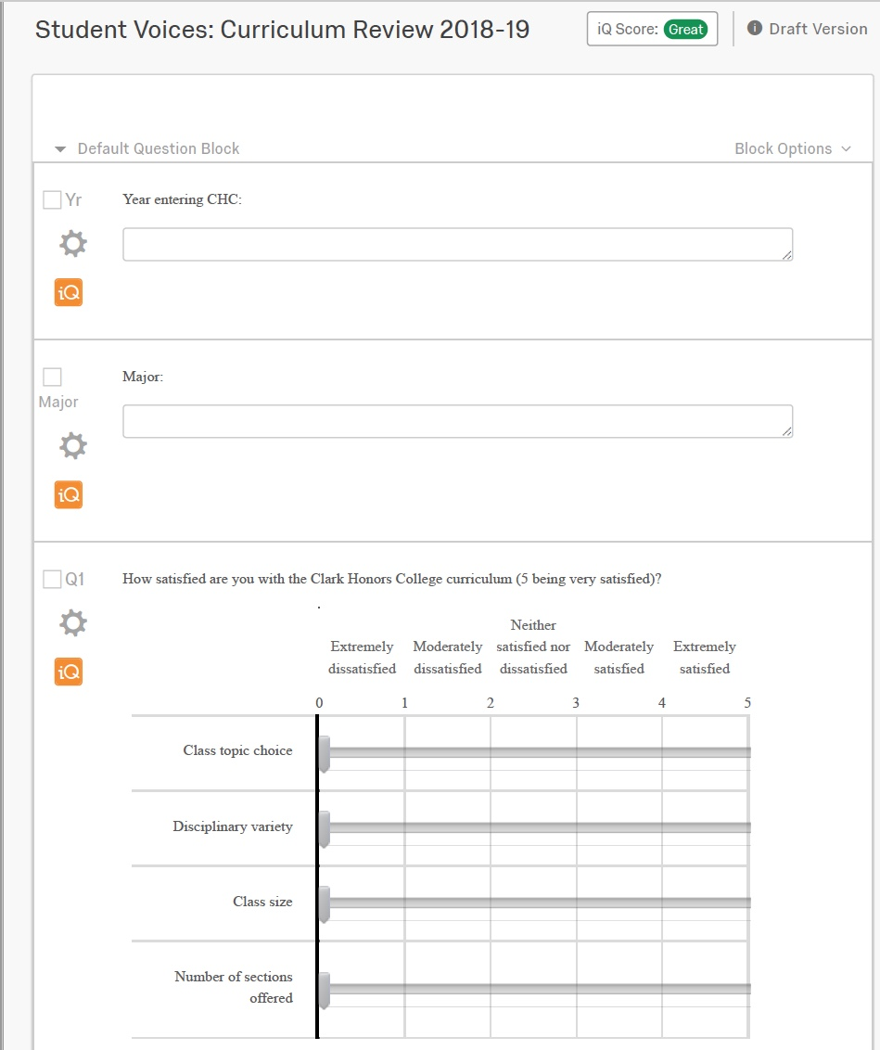
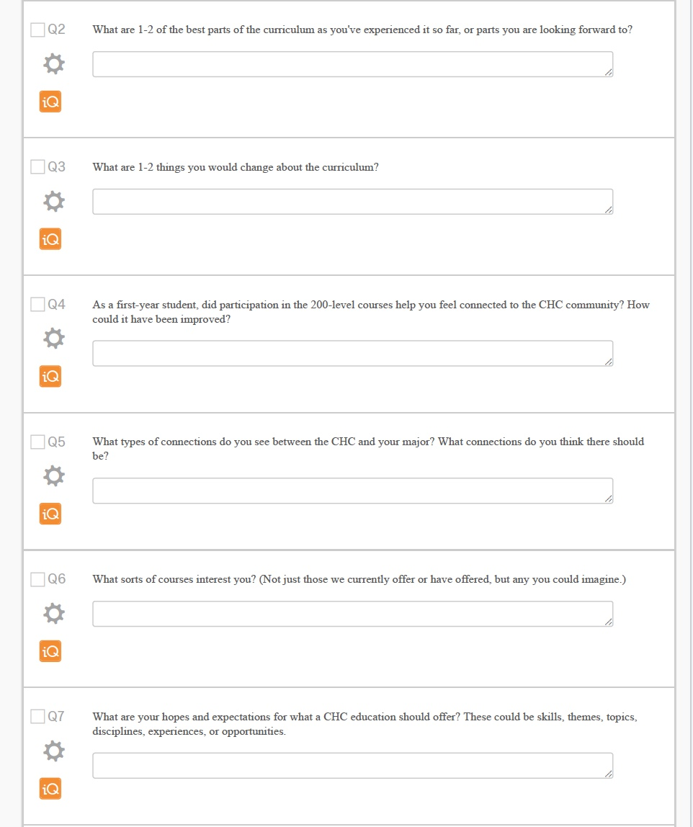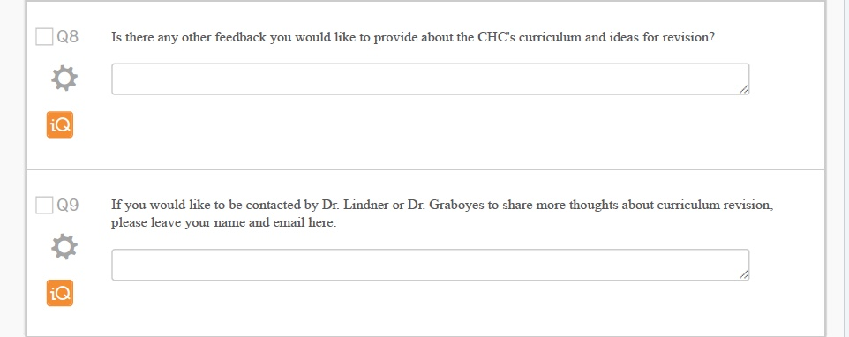

Appendix 2: Faculty Curriculum Survey
