Annual Departmental Assessment Report May 2021

Department or Program: Chemistry & Biochemistry
Academic Years of Report: 2019 - 2021
Department Contact Person for Assessment: Michael Koscho

Section 1: Learning Objectives Assessed for this Report

The learning objectives assessed during this period are described below as learning goals 1 and 2 and are the same for both our Chemistry and Biochemistry majors. Figure 1 documents how the number of students we serve has increased over the past 20 years peaking from 2013 to 2016.

Learning Goal 1: Master a broad set of chemical concepts concerning the fundamentals in the basic areas of the discipline (organic, inorganic, analytical, physical and biochemistry). Students will demonstrate an understanding of structure, chemical properties, and reactions of chemicals and biomolecules.

Learning Goal 2: Demonstrate a firm foundation in the conceptual, quantitative, and computational thinking that underlies the theories and models that form the basis for reasoning about molecular systems. Students should be able to connect this theoretical understanding to the experimental methods used to test those theories and models.

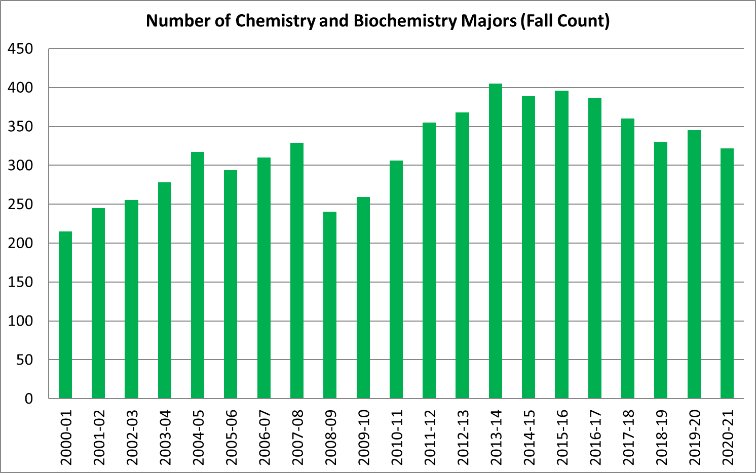
Figure 1. Number of Chemistry and Biochemistry Majors over Time. Shows the total number of chemistry majors and biochemistry majors per year since 2000.

Section 2: Assessment Activities

Learning Goal 1: Master a broad set of chemical concepts concerning the fundamentals in the basic areas of the discipline (organic, inorganic, analytical, physical and biochemistry). Students will demonstrate an understanding of structure, chemical properties, and reactions of chemicals and biomolecules.

Previously, our faculty identified and evaluated tools to assess the mastery of a broad set of chemical concepts for our majors. The American Chemical Society (ACS) – Division of Chemical Education Examinations Institute provides national exams that can be used to assess student performance at different stages of the chemistry curriculum. One advantage of this approach is that the exams institute provides a tool that compares the performance of our students with student performances from other US schools. This will enable us to track internal and external performance from year to year and potentially identify gaps in our curriculum.

Our faculty reviewed many ACS exams and chose the General Chemistry ACS exam (which is actually three exams that students take as their final exam for each term of General Chemistry), and the DUCK18 – 2018 Diagnostic of Undergraduate Chemical Knowledge—was chosen as a senior level exam. The General Chemistry exams were administered as the Final Exam for the first term of General Chemistry (CH 221) in the fall 2019. The ACS requires that the exams are given in person. Here is an excerpt from their website (https://uwm.edu/acs-exams/):

All ACS Exams (active or inactive tests, either parts or whole) must be administered in a secured, proctored environment and cannot be administered via a course management or other exam delivery system site.

The extension of this is that all ACS Exams (active or inactive tests; either parts or whole) cannot be scanned, copied, transcribed or otherwise coded or written into any system designed to deliver courses (and course content including assessments) to students, which includes course management systems. Additionally, all ACS Exams (active or inactive tests; either parts or whole) must be administered in a secured, proctored environment. All ACS Exams (active or inactive tests; either parts or whole) cannot be administered to students in a remote capacity, which includes sending students tests, having students check out tests or providing a test to a non-approved proctor.

Due to Covid-19 and the move to fully online final exams in the winter 2020 term we were unable to administer the final exam. We have also been unable to administer the final exam for the spring 2020 term and the full 2020-2021 academic year for the same reason. Once we are able to administer exams we will collect and analyze the data.

Learning Goal #2: Demonstrate a firm foundation in the conceptual, quantitative, and computational thinking that underlies the theories and models that form the basis for reasoning about molecular systems. Students should be able to connect this theoretical understanding to the experimental methods used to test those theories and models.

Because chemistry and biochemistry are experimental sciences, it is vital for students to undertake research projects. One conclusion from our previous assessment report was that we wanted to invest more resources into supporting and growing our undergraduate research community. During the Fall of 2018 we hosted our first ever meet-and-greet and we hosted a Faculty Research Showcase event during the Winter 2019 term. Our goal is to host community building events each quarter. For the Fall of 2019 and the Winter of 2020 we held our second annual meet-and-greet and the Faculty Research Showcase event. Unfortunately, during the 2020-2021 academic year we were unable to host any in person events. We did hold a virtual Faculty Research Showcase using the Gather.town online format. Where the in person events attracted about 100 student, only 35 students showed up to the online event.

The number of CH and BIC majors who are doing undergraduate research is shown in Figure 2. There was some growth in the number of undergraduate researchers comparing academic years 2018-2019 and 2019-2020. This growth dropped off dramatically in the Spring term of 2020 when all courses went to remote instruction due to Covid-19, and no one was allowed into the research labs for a period of time. Even after researchers were allowed back into the lab the number of people allowed at a time were limited. Typically, graduate students were prioritized over undergraduates in the laboratory. As more people have been allowed into the lab the numbers are recovering.

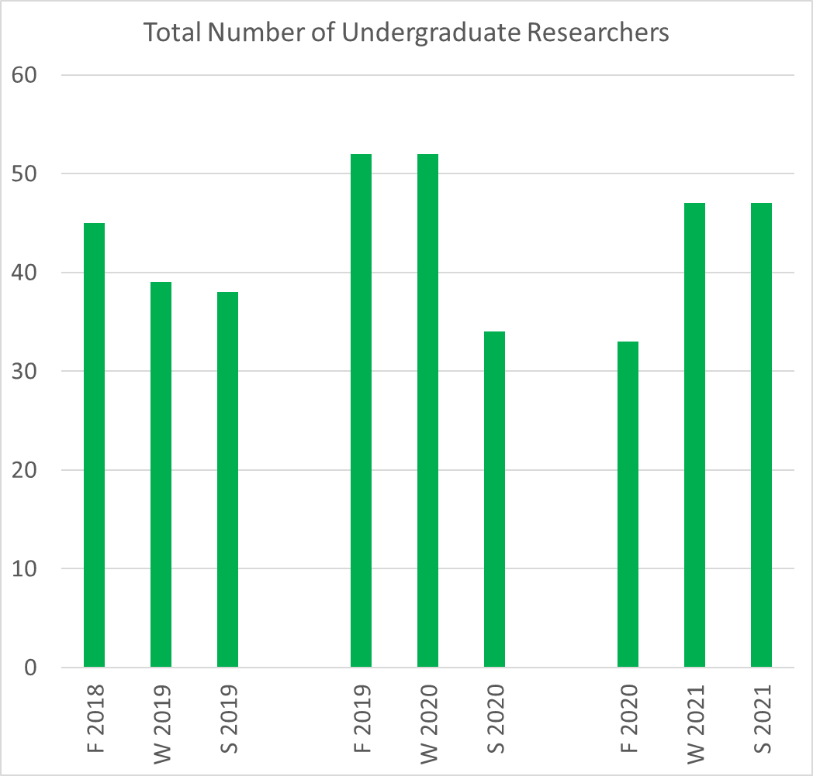
Figure 2. Number of Chemistry and Biochemistry Majors who are working in a research lab.

Section 3: Actions Taken Based on Assessment Analysis

As soon as we are allowed to, we will host quarterly events that bring together our undergraduates and faculty so that they can have informal discussions about research. We will continue to track the number of undergraduate researchers over time to assess its effectiveness. In addition, in order to fully asses the learning outcomes for these students we will be tracking the number of publications where the undergraduates are a co-author, and the number of research presentations given by the undergraduates at regional and national conferences.

Beginning fall 2021, we plan on administering the General Chemistry ACS exam in order to be able to compare our students’ performance with national averages. Additionally, we will determine a way to administer the DUCK18 senior level exam.

Section 4: Other Efforts to Improve the Student Educational Experience

We are increasing the number and diversity of upper division advanced electives for our majors. The lack of advanced electives, especially for our biochemistry majors, has been a significant challenge. We used to encourage our biochemistry majors to enroll in appropriate advanced electives offered in the Biology department but, due to capacity issues, Biology only reserves two seats per class for biochemistry majors. This drives our majors to change their major to Biology in order to get priority registration access or change to majors like human physiology that have fewer logistical challenges. In response to this we have submitted a proposal to change the structure of the advanced electives for the biochemistry major. The proposal was submitted in February 2021 and has been approved by the UO Committee on Courses to take effect Fall 2021. Biochemistry majors will now need to take at least two of their five advanced electives from CH 464, 465, 466, and 468. All of these courses require at least one term of the foundational biochemistry sequence, CH 461-463, as a prerequisite. In order for students to meet this requirements and graduate in a timely manner the department is planning on offering at least three of these courses each academic year.

In addition to advanced elective courses, the department also needs to offer advanced labs. This has been challenging given that the instructional lab space is currently at maximum capacity. Recently, with remodeling of the third floor of Klamath Hall, space has become available on the third floor of Onyx (since research labs are relocating into the newly remodeled space). Now that chemistry teaching labs can use some of this space, we will be able to add an array of advanced lab courses for our majors. Plans to teach an advanced inorganic lab and an advanced biochemistry lab are currently being developed.

Section 5: Plans for Next Year

As discussed above, we will begin assessing learning outcome #1 by using a comprehensive chemistry exams provided by the American Chemical Society (ACS). We will also continue to assess learning outcome #2 by tracking how many of our majors work in a research lab and tracking the number of presentations and publications that result from their research.

Budgetary implications include the costs for collecting and analyzing data, hosting quarterly events and purchasing ACS exams.

